Enjambed Internal Rhyme

🔄 What is Enjambed Internal Rhyme
# Source: AI Source: Provided by: [Data Path: Persons Table -> ID Column: 1, Name_En Column: Motasem Essam] -> From: [Chatgpt (GPT-4-turbo)] on [8/2/2025]
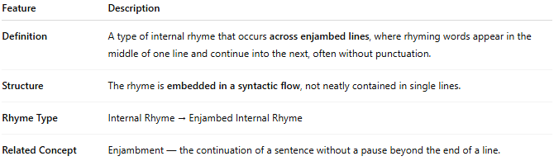
Feature | Description
Definition | A type of internal rhyme that occurs across enjambed lines, where rhyming words appear in the middle of one line and continue into the next, often without punctuation.
Structure | The rhyme is embedded in a syntactic flow, not neatly contained in single lines.
Rhyme Type | Internal Rhyme → Enjambed Internal Rhyme
Related Concept | Enjambment — the continuation of a sentence without a pause beyond the end of a line.

📝 Examples:
# Source: AI Source: Provided by: [Data Path: Persons Table -> ID Column: 1, Name_En Column: Motasem Essam] -> From: [Chatgpt (GPT-4-turbo)] on [8/2/2025]
She knew that fate would play
its part in dreams that fade away.
I stand alone and start to feel
the weight of silence, dark and real.
Here, the rhymes play–away and feel–real bridge over lines that are enjambed — there’s no pause between the lines, yet the rhyme is internal because it connects mid-sentence elements.

🎭 Effect in Poetry:
# Source: AI Source: Provided by: [Data Path: Persons Table -> ID Column: 1, Name_En Column: Motasem Essam] -> From: [Chatgpt (GPT-4-turbo)] on [8/2/2025]
- Enhances fluidity and natural speech patterns
- Avoids forced line breaks, keeping the rhyme subtle
- Helps maintain rhythmic continuity
- Offers a more modern or free-form poetic tone

✅ When to Use:
# Source: AI Source: Provided by: [Data Path: Persons Table -> ID Column: 1, Name_En Column: Motasem Essam] -> From: [Chatgpt (GPT-4-turbo)] on [8/2/2025]
- When you want rhymes to feel organic and uncontrived
- In narrative or conversational poetry
- When blending free verse style with rhythmic texture

